fBasic Box Filter 4000 

Please read through these operating instructions carefully to make sure that you can fully benefit from all features. We hope you will enjoy your new device!

▲TECHNICAL DATA

|  |  |
| --- | --- |
| For ponds up to | 4,000 litres |
| Filter dimensions, mounted (W x D x H) | 30 x 24 x 29 cm |
| Filter inlet | Ø 19 mm |
| Filter outlet | Ø 50 mm |
| Recommended Max Pump Flow (not included) | 3000 LPH |
| Recommended Hose size (not included) | 20mm |

The device has been developed for private use and not for industrial or commercial purposes. This filter system is used to support the biological self-cleaning of your garden pond. A satisfactory effect and function of this filter system is influenced by various operating conditions, factors. Such as many fish, few plants, a lot of direct sunlight and a high level of contamination can negatively influence the mode of operation and may significantly reduce the maximum pond water volume that can be effectively cleaned.

Do not use excessive force that can cause damage when tightening threaded unions.

See the illustration/drawing at the end of these use instructions.

The numbers and other information cited below in parentheses are based on this illustration.

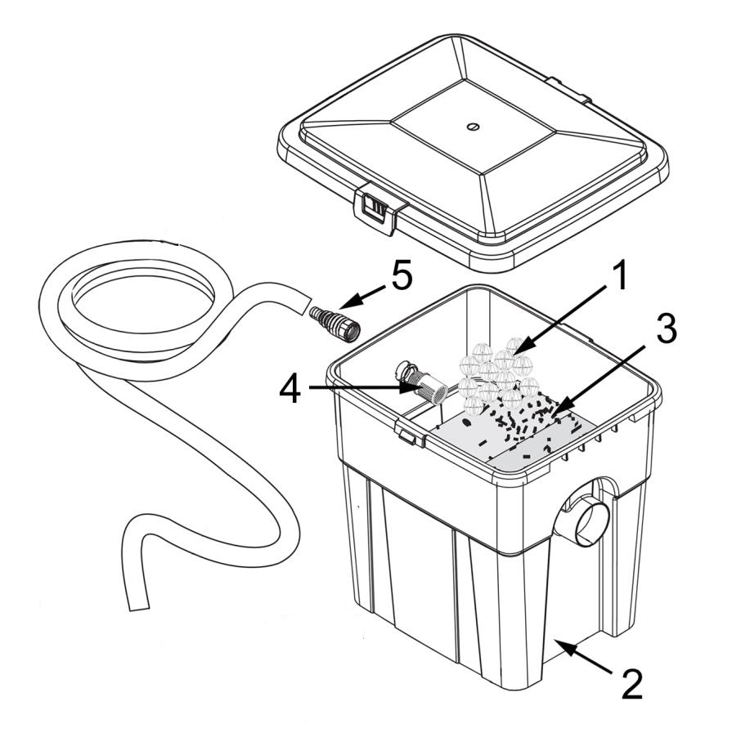

Filter is supplied with all necessary accessories. Place the container in the most suitable position an ensure that the outflow opening faces the pond itself.

▲ASSEMBLY:

Before performing any installation or maintenance tasks, disconnect the electrical devices immersed in the pond from the power source by pulling the plug out of the socket outlet.

First place the 16 Bioballs (1) in the designated place in the container (2).

Place the two filter sponges (3) in the area in front of the Bioballs in the space provided.

Use a hose and associated hose nozzles (5) to connect a pump.

★ATTENTION:

• Filter Box must be positioned OUTSIDE the pond (place at pond edge on a stable surface).

• If a drain hose or drain pipe is used, it should always be installed with a slope to the pond.

• Place the filter above the water level (filter outlet min. 15 cm above the water surface).

• The container should be placed horizontally on a solid substrate (stone slab).

• Ensure that it cannot fall into the water and that the installation area of the filter cannot be flooded.

• It is best to position the filter such that it will be in the shade.

• If the interior of your filter should become very hot, then its performance is reduced.

• For this filter system we recommend continuous operation (24 hrs a day), in the season (March to October).

▲**Cleaning the filter**

• The function of the filter system must be checked at regular intervals. Initially, the filter system should be checked daily. Leaves, grass, and debris can quickly clog the filter sponges. Select the cleaning intervals based on the type and the extent of contamination in your pond.

• Replace all filter mats (3) regularly (1x per season)

• If you notice a deterioration in water quality, a decreased delivery rate or water escaping from the cover, take the following steps:

1) Larger dirt particles collect on the bottom of the filter which must be removed.

2) Mechanical sponge filter: Take the sponges out of the filter (3) and rinse them with clean pond water. Place the sponges back over the Bioballs (1) in the correct horizontal position.

3) Biological filter: The Bioballs (1) Leave to accumulate healthy pond water bacteria. Can be rinsed with pond water if they exhibit heavy dirt deposits.

•Annual maintenance: Carry out a thorough cleaning of the filter at least once a year. Empty the filter, remove all the dirt on the bottom and wash all the filter materials with water.

**Limited Warranty**

This product is guaranteed for a period of 12 months from the date of purchase for material or manufacturing defects. The guarantee covers the substitution of defective parts. However, the guarantee is considered null and void in the case of improper use, improper handling or negligence on the part of the buyer. If your PondXpert item fails please take it back to the retail outlet from where it was purchased. You will be required to provide your receipt/proof of purchase. This does not affect your statutory rights.

PondXpert

A3 Bentley Avenue

Billingham

TS23 4BU

UK 01642 370898

